**Report of Mini Project**

**Title - Olympics Data Analysis**

**Name – Sahil Bhandari**

**Intern id – STB03-T0031**

**Project Overview** - In this project, we embark on a comprehensive exploration of Olympic data leveraging the analytical capabilities of Power BI. By harnessing the vast dataset encompassing decades of Olympic history, we aim to unveil meaningful insights, trends, and patterns associated with athlete performances, medal distributions, and demographic factors. The Power BI platform serves as our analytical powerhouse, allowing us to transform raw data into visually compelling narratives, fostering a deeper understanding of the intricate dynamics that shape the Olympic Games over the years. Through intuitive dashboards and interactive reports, this project aspires to offer a holistic view of Olympic data, providing stakeholders, enthusiasts, and decision-makers with a valuable resource for informed analysis and strategic insights.

**Dataset** - we're using a dataset that includes 2,71,116 players from 67 different sports. People from 208 countries are part of this dataset, showing a wide variety of sports and a global reach

**Tools Used** - We're utilizing Power BI to create visual representations of the data. This data will help us analyze and understand trends in sports, athlete performances, and how different countries participate

**Screenshots of visualizations**

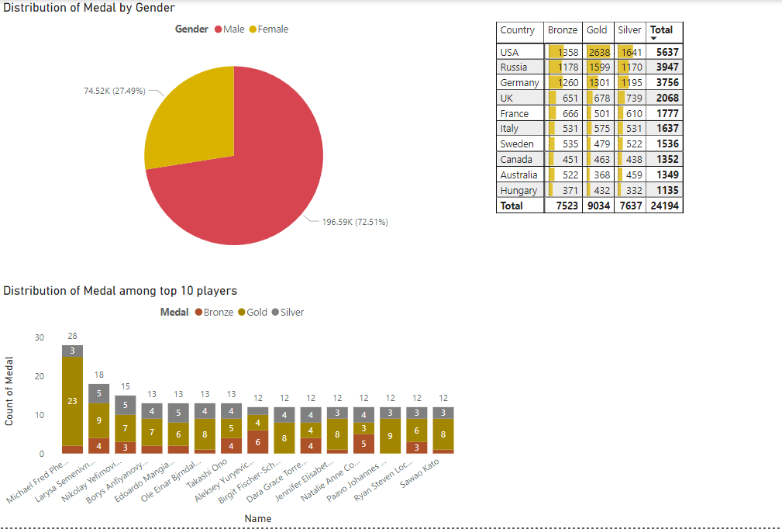

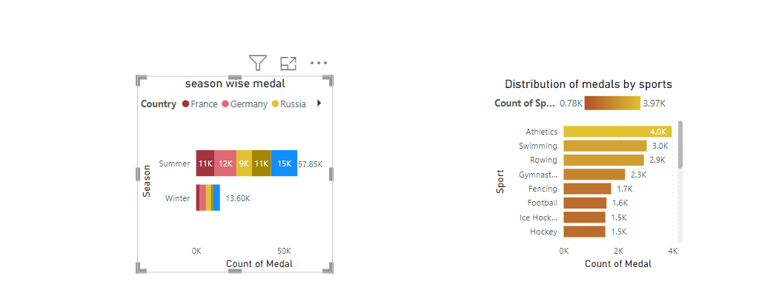

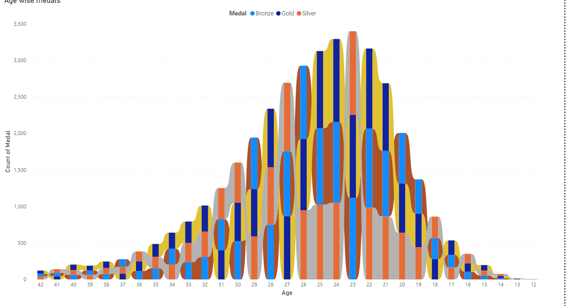

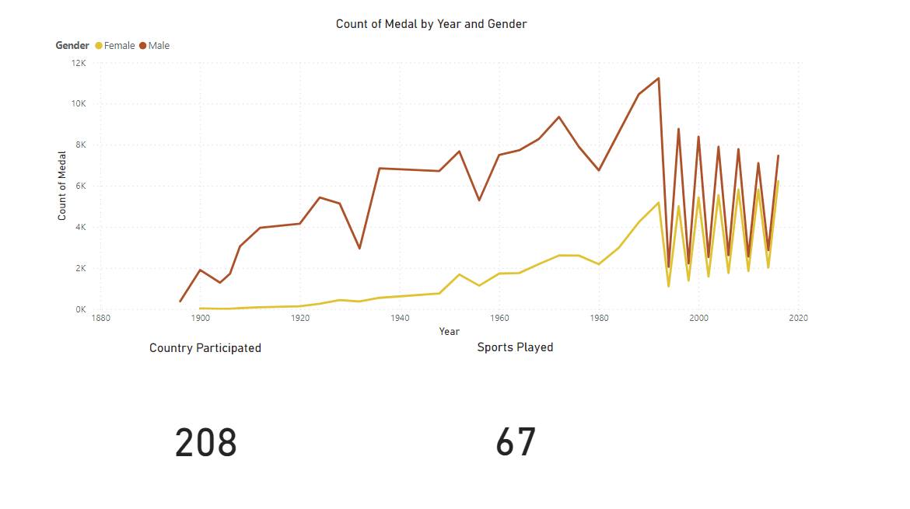

**Dashboard:** It is a consolidated visual display of key metrics and insights, enabling users to monitor and analyze data in a user-friendly interface.

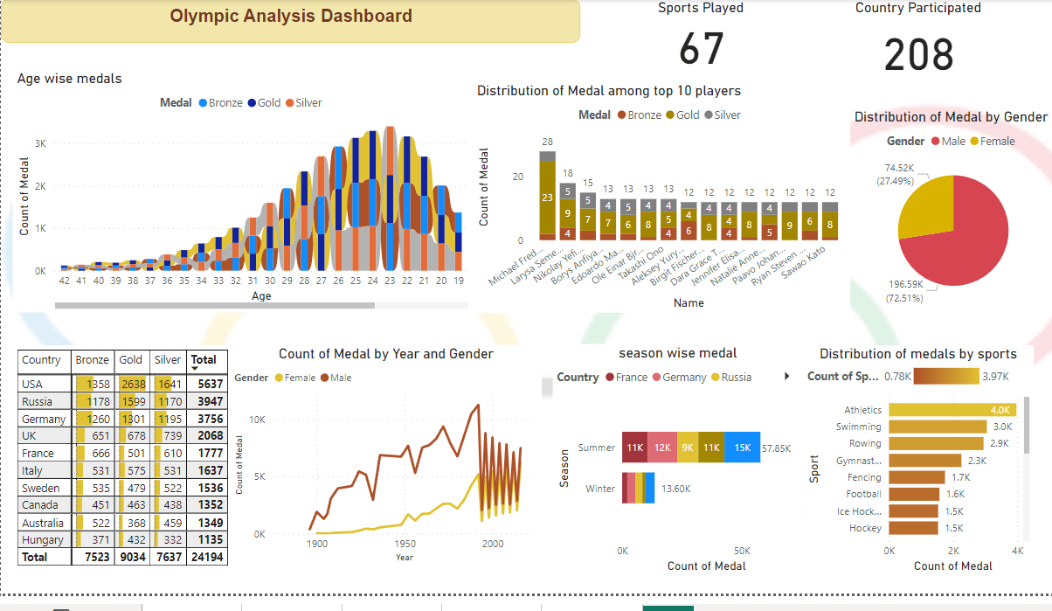

**Thank You!!!**